- Download lstio
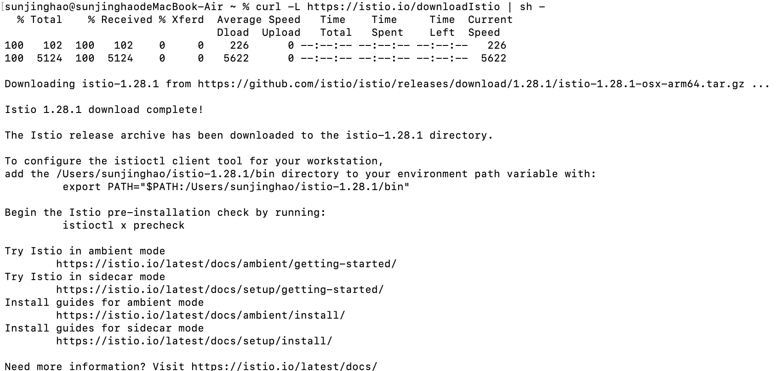
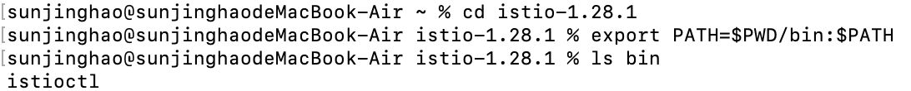

- Install lstio
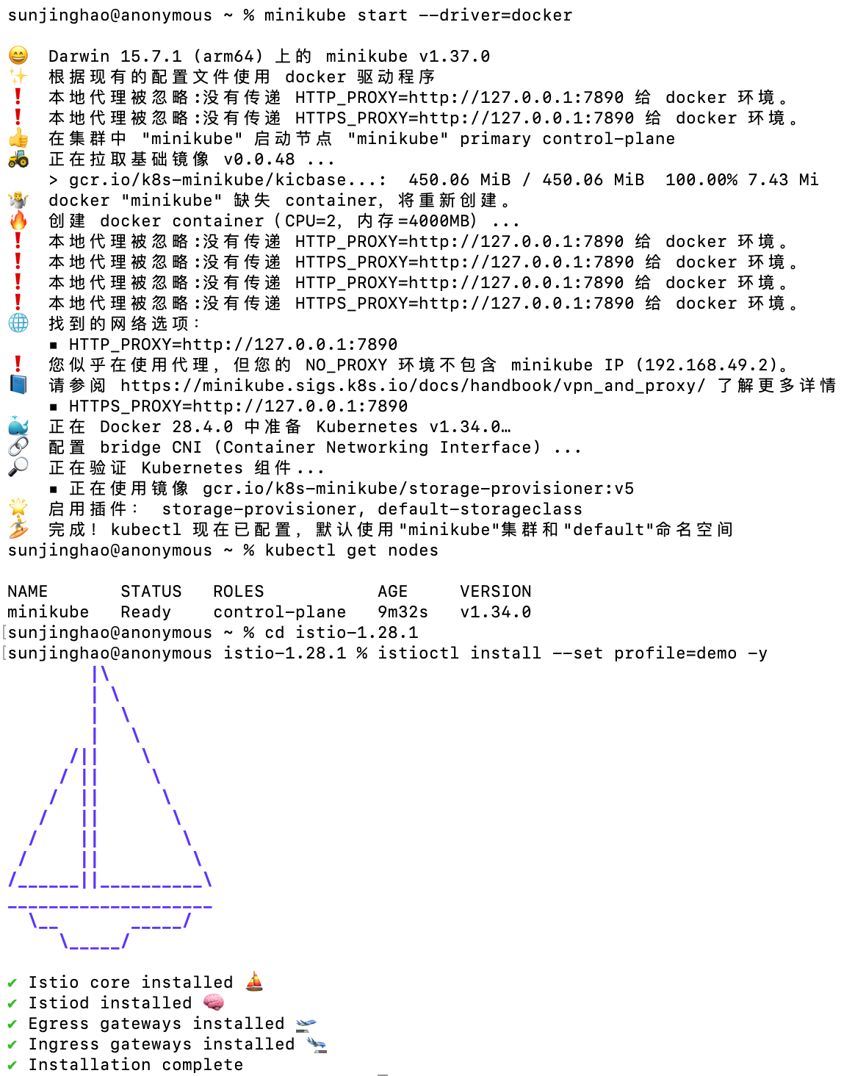

- check the pods
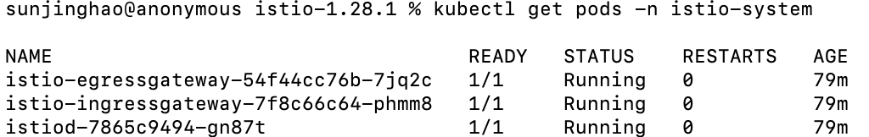

- Enable sidecar injection for the default namespace

- Deploy the official sample application Bookinfo
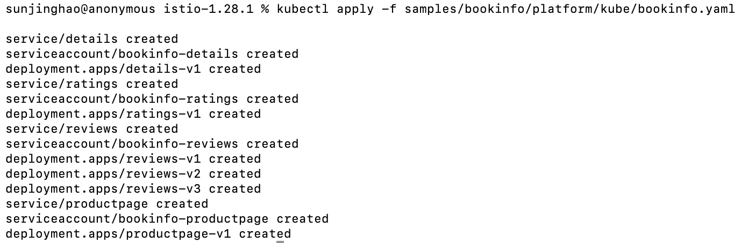

- Confirm that Bookinfo Pods are functioning properly
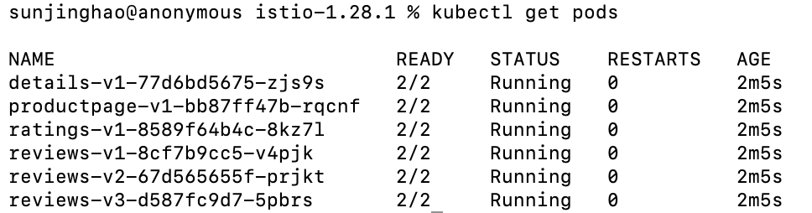

- Create lstio Gateway

- Confirm the Gateway and VirtualService
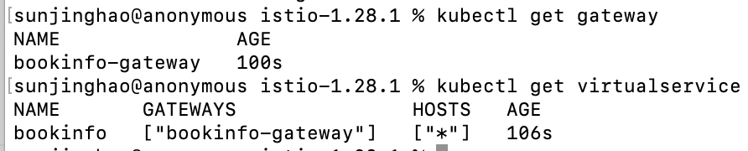

- Visit Bookinfo application



- Refresh the page to verify the microservice communication


- Open lstio Dashboard(Kiali)
